Simulation/Verification Of L1 Cache Controller
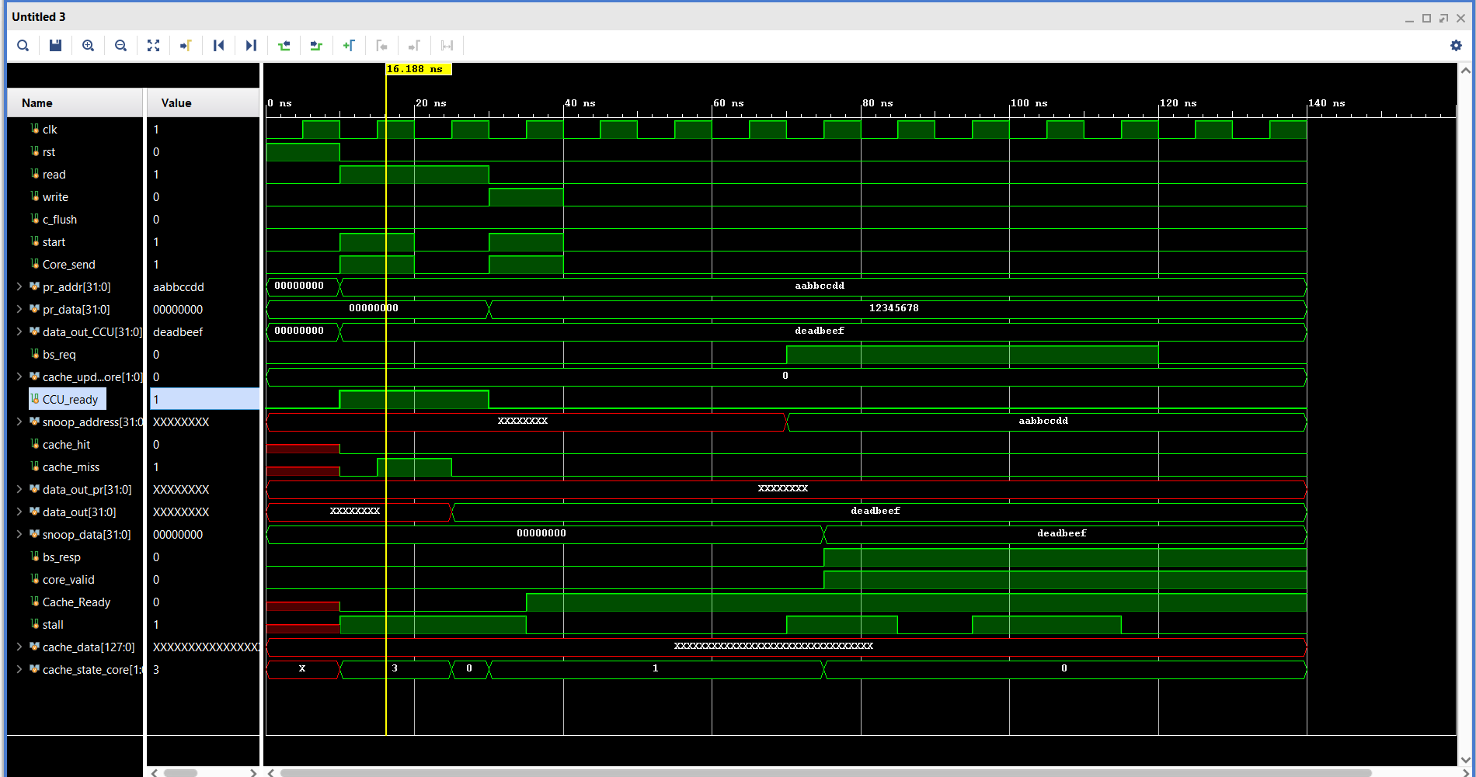
All tests passed!

